Ex1:

<%@ page language=*"java"* contentType=*"text/html; charset=ISO-8859-1"*

pageEncoding=*"ISO-8859-1"*%>

<%@ page import = *"java.io.*,java.util.*"* %>

<html>

<head>

<title>HTTP Header Request Example</title>

</head>

<body>

<center>

<h2>HTTP Header Request Example</h2>

<table width = *"100%"* border = *"1"* align = *"center"*>

<tr bgcolor = *"#949494"*>

<th>Header Name</th>

<th>Header Value(s)</th>

</tr>

<%

Enumeration headerNames = request.getHeaderNames();

**while**(headerNames.hasMoreElements()) {

String paramName = (String)headerNames.nextElement();

out.print("<tr><td>" + paramName + "</td>\n");

String paramValue = request.getHeader(paramName);

out.println("<td> " + paramValue + "</td></tr>\n");

}

%>

</table>

</center>

</body>

</html>

OUTPUT:

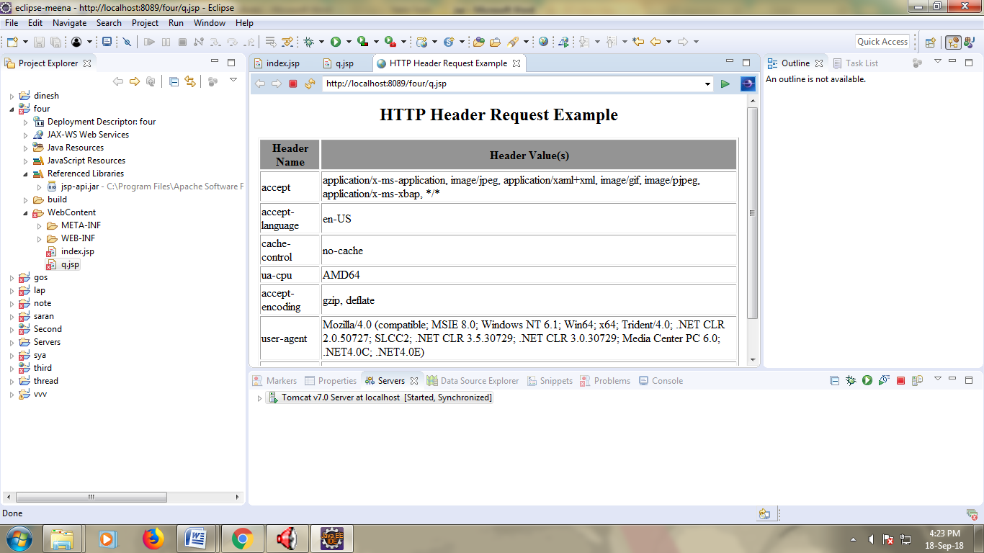

RESULT:

Ex2:

<%@ page language=*"java"* contentType=*"text/html; charset=ISO-8859-1"*

pageEncoding=*"ISO-8859-1"*%>

<%@ page import = *"java.io.*,java.util.*"* %>

<html>

<head>

<title>Auto Refresh Header Example</title>

</head>

<body>

<center>

<h2>Auto Refresh Header Example</h2>

<%

// Set refresh, autoload time as 5 seconds

response.setIntHeader("Refresh", 5);

// Get current time

Calendar calendar = **new** GregorianCalendar();

String am_pm;

**int** hour = calendar.get(Calendar.HOUR);

**int** minute = calendar.get(Calendar.MINUTE);

**int** second = calendar.get(Calendar.SECOND);

**if**(calendar.get(Calendar.AM_PM) == 0)

am_pm = "AM";

**else**

am_pm = "PM";

String CT = hour+":"+ minute +":"+ second +" "+ am_pm;

out.println("Current Time is: " + CT + "\n");

%>

</center>

</body>

</html>

OUTPUT:

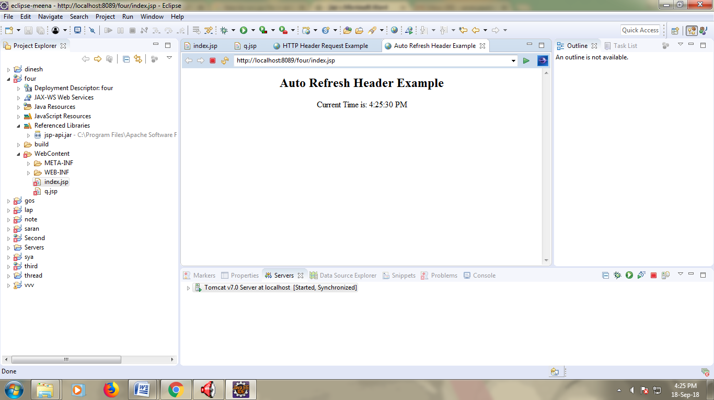

RESULT:

Ex3:

Main.jsp:

<%@ page language=*"java"* contentType=*"text/html; charset=ISO-8859-1"*

pageEncoding=*"ISO-8859-1"*%>

<%

// Create cookies for first and last names.

Cookie firstName = **new** Cookie("first_name", request.getParameter("first_name"));

Cookie lastName = **new** Cookie("last_name", request.getParameter("last_name"));

// Set expiry date after 24 Hrs for both the cookies.

firstName.setMaxAge(60*60*24);

lastName.setMaxAge(60*60*24);

// Add both the cookies in the response header.

response.addCookie( firstName );

response.addCookie( lastName );

%>

<html>

<head>

<title>Setting Cookies</title>

</head>

<body>

<center>

<h1>Setting Cookies</h1>

</center>

<ul>

<li><p><b>First Name:</b>

<%= request.getParameter("first_name")%>

</p></li>

<li><p><b>Last Name:</b>

<%= request.getParameter("last_name")%>

</p></li>

</ul>

</body>

</html>

Hello.jsp:

<%@ page language=*"java"* contentType=*"text/html; charset=ISO-8859-1"*

pageEncoding=*"ISO-8859-1"*%>

<html>

<body>

<form action = *"main.jsp"* method = *"GET"*>

First Name: <input type = *"text"* name = *"first_name"*>

<br />

Last Name: <input type = *"text"* name = *"last_name"* />

<input type = *"submit"* value = *"Submit"* />

</form>

</body>

</html>

OUTPUT:

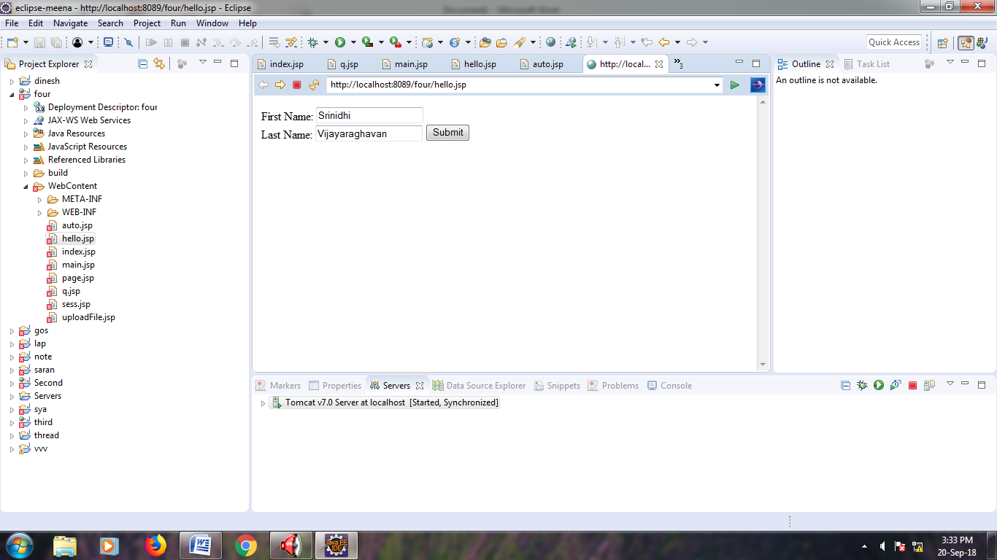

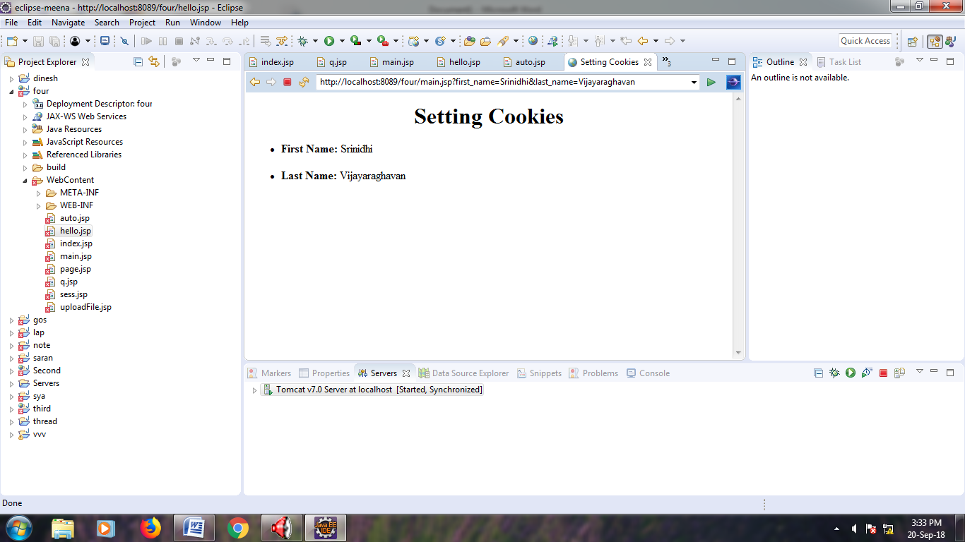

RESULT:

Ex4:

<%@ page language=*"java"* contentType=*"text/html; charset=ISO-8859-1"*

pageEncoding=*"ISO-8859-1"*%>

<%@ page import = *"java.io.*,java.util.*"* %>

<%

// Get session creation time.

Date createTime = **new** Date(session.getCreationTime());

// Get last access time of this Webpage.

Date lastAccessTime = **new** Date(session.getLastAccessedTime());

String title = "Welcome Back to my website";

Integer visitCount = **new** Integer(0);

String visitCountKey = **new** String("visitCount");

String userIDKey = **new** String("userID");

String userID = **new** String("ABCD");

// Check if this is new comer on your Webpage.

**if** (session.isNew() ){

title = "Welcome to my website";

session.setAttribute(userIDKey, userID);

session.setAttribute(visitCountKey, visitCount);

}

visitCount = (Integer)session.getAttribute(visitCountKey);

visitCount = visitCount + 1;

userID = (String)session.getAttribute(userIDKey);

session.setAttribute(visitCountKey, visitCount);

%>

<html>

<head>

<title>Session Tracking</title>

</head>

<body>

<center>

<h1>Session Tracking</h1>

</center>

<table border = *"1"* align = *"center"*>

<tr bgcolor = *"#949494"*>

<th>Session info</th>

<th>Value</th>

</tr>

<tr>

<td>id</td>

<td><% out.print( session.getId()); %></td>

</tr>

<tr>

<td>Creation Time</td>

<td><% out.print(createTime); %></td>

</tr>

<tr>

<td>Time of Last Access</td>

<td><% out.print(lastAccessTime); %></td>

</tr>

<tr>

<td>User ID</td>

<td><% out.print(userID); %></td>

</tr>

<tr>

<td>Number of visits</td>

<td><% out.print(visitCount); %></td>

</tr>

</table>

</body>

</html>

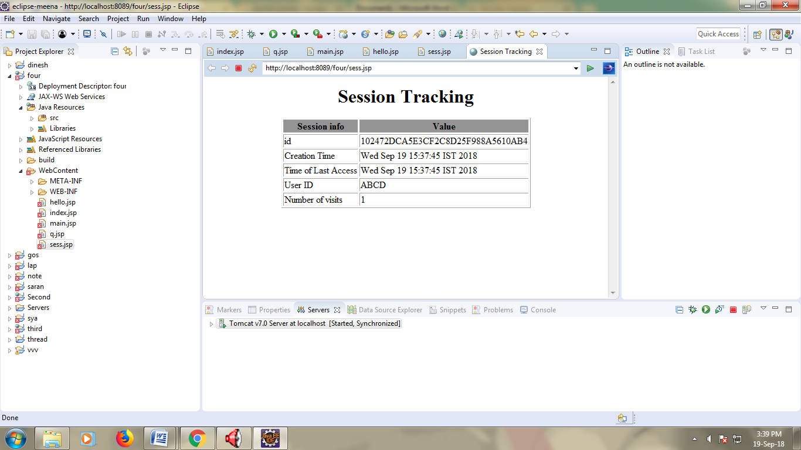

RESULT:

Ex5:

<%@ page language=*"java"* contentType=*"text/html; charset=ISO-8859-1"*

pageEncoding=*"ISO-8859-1"*%>

<html>

<head>

<title>File Uploading Form</title>

</head>

<body>

<h3>File Upload:</h3>

Select a file to upload: <br />

<form action = *"UploadServlet"* method = *"post"*

enctype = *"multipart/form-data"*>

<input type = *"file"* name = *"file"* size = *"50"* />

<br />

<input type = *"submit"* value = *"Upload File"* />

</form>

</body>

</html>

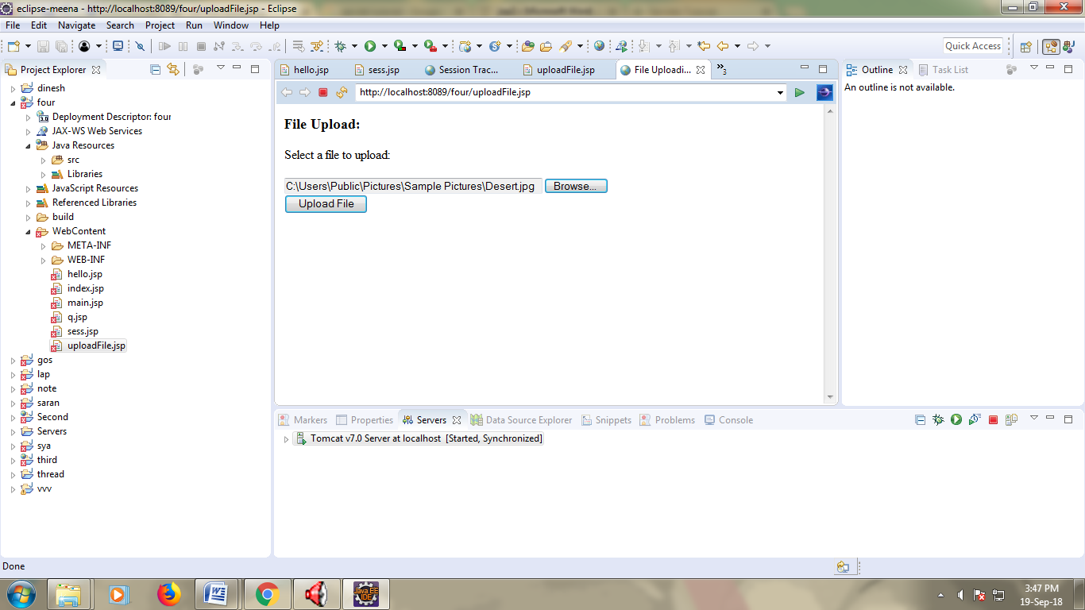

RESULT:

Ex6:

<%@ page language=*"java"* contentType=*"text/html; charset=ISO-8859-1"*

pageEncoding=*"ISO-8859-1"*%>

<%@ page import = *"java.io.*,java.util.*"* %>

<html>

<head>

<title>Page Redirection</title>

</head>

<body>

<center>

<h1>Page Redirection</h1>

</center>

<%

// New location to be redirected

String site = **new** String("http://www.google.com");

response.setStatus(response.SC_MOVED_TEMPORARILY);

response.setHeader("Location", site);

%>

</body>

</html>

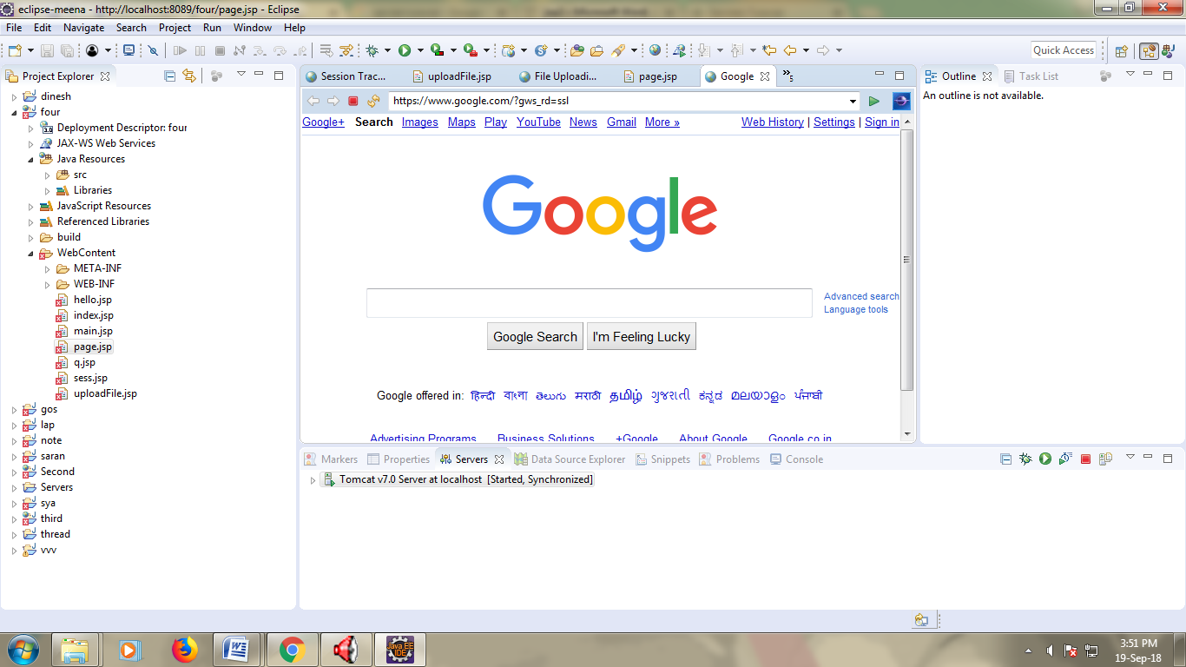

RESULT:

Ex7:

<%@ page language=*"java"* contentType=*"text/html; charset=ISO-8859-1"*

pageEncoding=*"ISO-8859-1"*%>

<%@ page import = *"java.io.*,java.util.*"* %>

<html>

<head>

<title>Auto Refresh Header Example</title>

</head>

<body>

<center>

<h2>Auto Refresh Header Example</h2>

<%

// Set refresh, autoload time as 5 seconds

response.setIntHeader("Refresh", 5);

// Get current time

Calendar calendar = **new** GregorianCalendar();

String am_pm;

**int** hour = calendar.get(Calendar.HOUR);

**int** minute = calendar.get(Calendar.MINUTE);

**int** second = calendar.get(Calendar.SECOND);

**if**(calendar.get(Calendar.AM_PM) == 0)

am_pm = "AM";

**else**

am_pm = "PM";

String CT = hour+":"+ minute +":"+ second +" "+ am_pm;

out.println("Crrent Time: " + CT + "\n");

%>

</center>

</body>

</html>

